Recent Experiences


Edgar Zeijlemaker

ING PSS Payment Services  Senior Project Manager  - Responsible Lead for the OPS migration, implementation and delivery for ING Belgium in the context of the replacement of the global SWIFT/International payments engine and process offshoring to ING HUBS. | 11-2024 - current
 ABN AMRO – Detecting Financial Crime (DFC)  Senior DevOps/agile coach  - Leveraging data driven DevOps, Agile and Product Management WoW, reliability Engineering with teams and Leadership teams in value streams implementing WoW, DORA Metrics, SAFe and Portfolio Mgt (Jira Align champion, setup DFC Portfolio Mgt) | 05-2021 / 07-2024
Program Manager/Lead Transaction Monitoring - DNB Remediation Delivery  - Responsible for the E2E delivery (Compliance, Group Audit AML Sanctions, Legal, Retail business, IT & Design, Data Science/ML, TM/KYC-CDD Operations) of the AML/Transaction Monitoring remediating on DNB Wwft findings for ABN AMRO Retail Banking.  Program Manager AI Technology stream - DFC Operations Transformation  - Responsible for the vision, delivery and realisation of data tooling, including replatforming (private cloud to Azure) and change portfolio towards Future State Architecture | 03-2020 / 05-2021
 Radiuz / Amaze (AutoBinck)  Program Manager & Product Owner Amaze Mobility startup | 09-2019 / 02-2020
- Program setup/portfolio creation and contract finalization, aligning both business roles, business requirements and IT efforts for the 3-year roadmap/ €4m budget of the Amaze Mobility program
- Project description
- Program setup and governance (Prince2/hybrid agile)
- Creation of business plan and IT transformation plan
- Develop product proposition (business, IT, partners). Initiate new Data architecture service environment with TNO/IenW and app development
- coordinating the legal and business process for a new legal entity and collaboration contract between consortium partners and Municipality of Amsterdam.
ING - D&CS Lead Product Owner agile Test/implementation  ING  - Responsible for improving and building a backlog for the Document & Content Services Tribe squads’ (15) testing capabilities, ensuring testing capabilities aligned with cross domain Unite integration program and testing skills and culture. | 03-2018 / 07-2019
ING - Sr. Product Owner Document & Content Services  ING | 09-2017 / 04-2018
- Product Owner for two DevOps teams – Document Management & processing, RPA & Machine Learning focussing on: Growing Continuous Improvement, developing Scaled Agile, building high performance teams, managing backlogs and creating Product vision & roadmap, build team governance.



 | Business address  EZ Consulting  Abeelstraat 35  1741TJ Schagen  The Netherlands
 | Telephone  +31 (0) 621 538 850
 | Email  info@ezconsulting.nl
 | Website  www.ezconsulting.nl  LinkedIn  linkedin.com/in/zeijlemaker

SUMMARY
Edgar is a pragmatic and goal oriented senior project/program manager and experienced DevOps/ agilest with strong commitment and persuasion. With both an analytical and pragmatic approach but for all, a people oriented approach, he has the ability to lead teams in a communicative and emphatic fashion and achieve the required change for an organization. Business improvement & delivery excellence are the key goals in Edgar’s endeavours and can deliver these in both a classic Prince2 fashion as well in an agile/DevOps environment.

Earlier Experiences
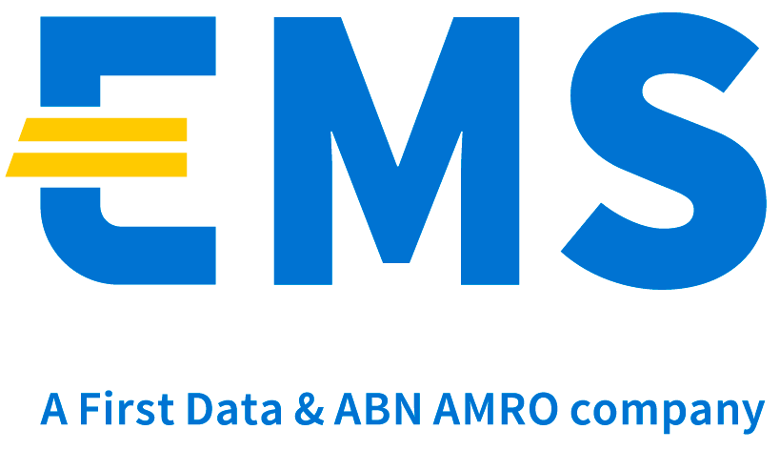 European Merchant Services | 2017
Interim Senior Project manager
Managing three major delivery projects for a fast growing Payment Service Provider: My EMS Merchant Portal and messaging, ABN AMRO Internet Wallet migration, digitalisation of Boarding processes (IT4IT).

Methodology Prince2 /Agile development
Team composition External vendor, First Data, Product Managers
- Project description
- Iterative evolution of features in the current MVP merchant portal
- Managing second stage of product migration
- Foundation activities for boarding process improvements
- Stakeholders
- External parties (ABN AMRO, First Data, Infosys)
- Product Management EMS, First Data (IT vendor), Compliance
Sabbatical – 6mo | 2017
ABN AMRO – Interest Condition Management & Capabilities | 2016
Lead Product Owner
Delivery Lead for technical development and business implementation of new IT architecture
Methodology Cross domain Scaled Agile/DevOps implementation (SAFe/Nexus). Direct report to Board of Directors
Team composition 5 product Owners, 5 SCRUM teams, external vendors TCS, IBM, Enterprise architects
Budget EUR 1.5 mio (2016), EUR 1.7 mio (2017)
- Project description
- Backlog of changes to existing applications for selected client groups to support negative interest
- Create structural new build of modular Java applications, mainframe and infrastructure for interest calculation.
- Stakeholders
- Operations, Product management Cash Management Retail en Wholesale, Finance ALM/Treasury, IT Solutions
- Result
- 2 program increments, Nexus Agile framework
- Approved architecture design
- Working models new Product administration & Interest Management and Capabilities engine

Senior Project Manager (E2E/cross domain) | 2011 – 2015
- Product Development – Delivery BASEL business product “31 Days Business Savings”
- Internet Banking/Mobile banking – Achieving Accrued Interest features
- Financial Reporting/Regulatory – AQR Core Banking data delivery
- Reconciliation Data Sources – Realization of data source connectivity with Core Banking mainframe (IT4IT)
- Financial Reporting – Achieving Daily Balance reporting applic. for ABN AMRO ledger
- Product Development – Delivering new product/service: “Pin Sparen”
- Regulatory – Delivery of Target Balancing/Notional pooling IFRS regulatory compliance (IT4IT)
- New architecture – Origination of stand-alone Core Banking data warehouse (IT4IT)

+31(0) 621 538 850 | EDGAR ZEIJLEMAKER | info@ezconsulting.nl

Earlier Experiences
ABN AMRO – Enterprise Service Bus | 2015 - 2016
Lead Product Owner Digital Integration
Realisation + implementation TOPS2020 Enterprise Service Bus and creation of CoE Service Oriented Architrecture
Methodology Prince2 / Agile PM
Team composition 3 operational SCRUM Dev teams, external vendor team Infosys, IBM Infra team, IIB architect
Budget EUR 1.4mio (excluding Infra budget 1 mio)
- Project description
- Realisation middleware IBM Enterprise Service Bus and IIB infra, plus IBM Service repository (Java)
- Set up IT subdomain, maintenance organisation, governance, work processes and procedures
- Operationalize and ‘manage’ Agile DEV Scrum teams
- Act as ESB Product Owner for PSD2 API, XS2A projects, Topicus FinanForce implementation and Securities back office
- Stakeholders
- IBM Infra
- Bankwide IT domains
- IT Services
- Board of TOPS IT
- Result
- Delivered operational and approved ESB middleware and IIB infrastructure within time and budget
- Operational Service repository (WSRR)
- 7 active service operations and interfaces with data consumers
- Functional Maintenance implemented: Processes, FM team staffing and connected to enterprise service management applications Service Now, Splunk
- Pre-RTS PSD2 – backend connectivity

Integration Program ABN AMRO – Fortis Bank (Retail, Wholesale and ECT) | 2009 – 2011
Senior Project Manager (E2E/cross domain)
- Domain Execution Manager - Integration lead for Core Banking
- Program Manager Testing – Set up of testing program with vendors
- Project Manager Migration Solutions Billing - Achieving migration solutions
 | 2007 – 2009

Manager Financial Services
- Project Manager - MyING TANGO Readiness, PID phase ING SoDC Securities and PMO/ Sharepoint implementation
 | 2007 – 2007
Manager
- Project Manager - Delivery of SOX Risk Reporting framework ING Real Estate
- Project Manager PID phase ING SoDC Retail Securities
- Project Manager – SoDC Retail Securities Sharepoint implementation Brussels & Amsterdam

Language skills
Dutch – Native speaker/primary fluent
English – Advanced
German – Limited working proficiency
French - Conversational

+31(0) 621 538 850 | EDGAR ZEIJLEMAKER | info@ezconsulting.nl

Employment experience
EZ Consulting | 2009 - current
- Freelance
Accenture | 2007 - 2009
- Manager, CSG Financial Services
Altran CIS | 2007 – 2007
- Senior Consultant BPM & BPI
Fortis Bank | 2001 – 2007
- Project Manager business
- Branch Manager
Rabobank | 1999 – 2001
- Manager, Personal Banking & SME
ABN AMRO Bank | 1996 - 1999
- Branch Manager

Education
 UNIVERSITY of AMSTERDAM | 1986 - 1993
- Masters degree European Studies – Major: English literature, European Law, European Integration
Graduation thesis: “A legal and democratic decomposition of the Maastricht EU Treaty”

Training & Certifications
- TOGAF 9 Level 1 & Level 2
- Data Protection Officer (GDPR) – PECB Preliminary certification
- Professional SCRUM master (PSM I)
- Prince2 Foundation & Practitioner
- In-company training Accenture – managerial MBA level

- NIBE – Money Laundering prevention
- KPMG – Basic Administrative Organisation, Fortis Bank – Leadership development program
- NIBE – Business Financing, Berenschot – Managing Programs and Projects
- ABN AMRO – Banking products, Database marketing, Total Quality Management (TQM)
- Management Training ABN AMRO, NIBE – Algemene Opleiding Bankbedrijf

Skills
- Management:  Business/IT Project- & program management  CICD, Process flow  Interim Management  Change Management  Agile Coaching & transformation  Transaction Monitoring / KYC/CDD / Sanctions  - Functional:  Certified Professional Scum Master  Target Balancing/ Notional Pooling  Service Oriented Architecture (SOA),  - Project environments and Tooling experience:  JIRA, ServiceNow, Clarity, Mainframe, Documentum, TIBCO  PowerBI, JIRA Align Portfolio Mgt | Agile/SCRUM  DevOps  SAFe  Nexus  Mixed on-/offsite environments  Certified Prince2 Practitioner  Business Process Management  CMMi/LEAN,  PSD2 / GDPR  AzureDevops  MS Project  IIB, IMS, Staffware, Engage One,  Compliance

+31(0) 621 538 850 | EDGAR ZEIJLEMAKER | info@ezconsulting.nl

2011 – 2013
2002 – 2006

